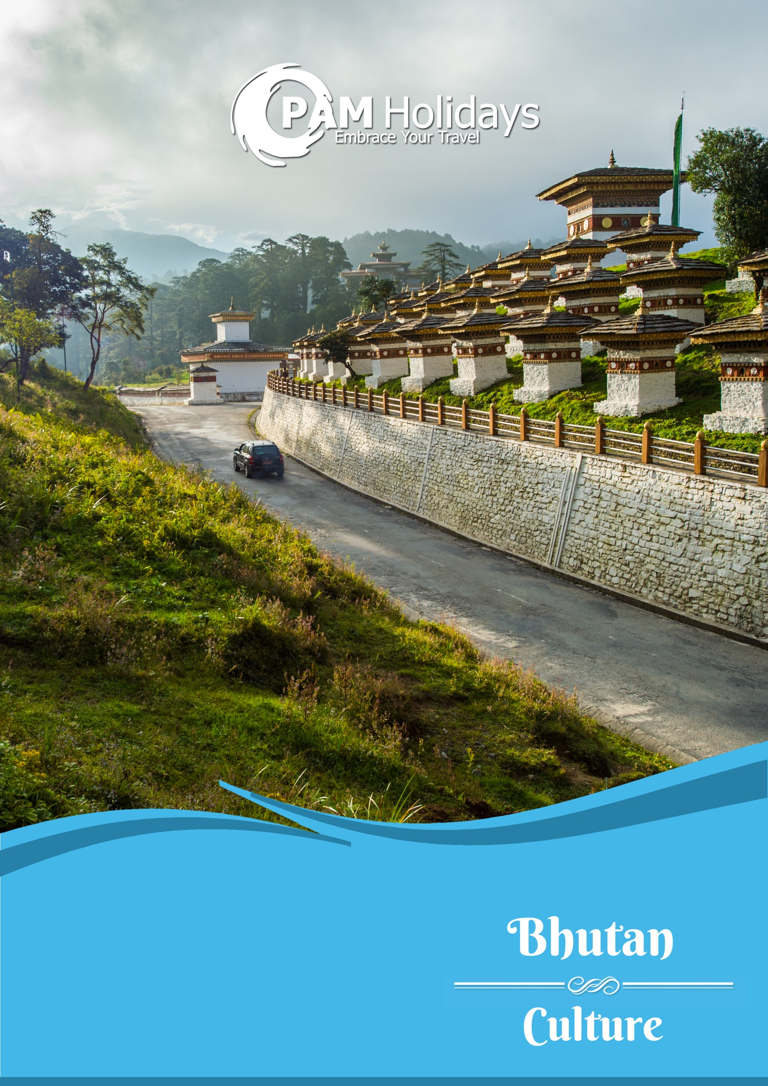

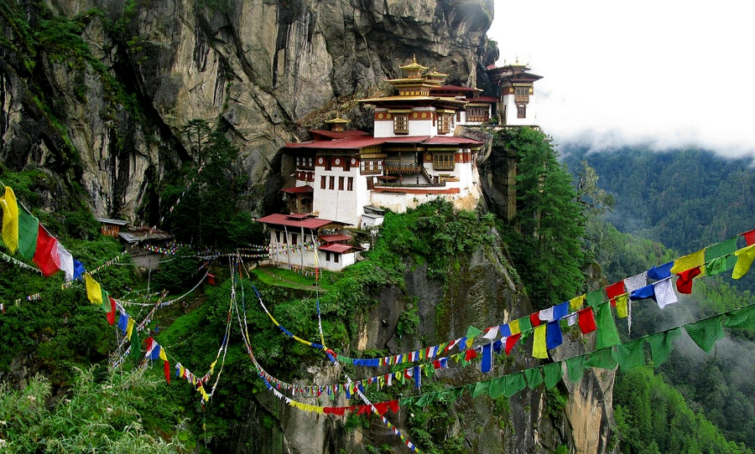

**$39,188+**

**Bhutan 7 Days 6 Nights Package**

**不丹7日6夜套票**

Valid for departure: Till 31Dec15

**Basic Information:**



|  |  |
| --- | --- |
| Weather:  氣溫: | Average – November to March 13°C / April to October 25°C  平均 – 11至3月13°C / 4至10月 25°C |
| Season:  氣候: | Mar-May: Cloudier with rain / Jun-Aug: Summer / Sep-Nov: Cool / Dec-Feb: Freezing  3-5月: 天陰有雨 / 6 - 8月: 夏季 / 9-11月: 清爽 / 12-2月 嚴寒 |
| Time Difference:  時差: | -2 hours |
| Distance from HK:  與香港相距 | Approx. 2,452 km  約2,452公里 |
| Flight Duration:  航班飛行時間: | Approx. 3 hours 40 minutes  (Bangkok – Bhutan)  約3小時40分鐘  (曼谷至不丹) |
| Visa:  簽證: | Required 需要  Details詳情 🡪 <http://www.tourism.gov.bt/plan/visa> |

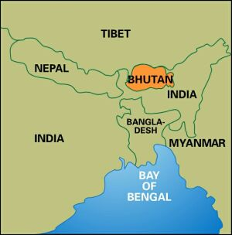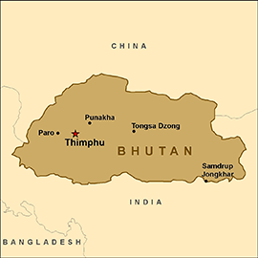

|  |  |  |  |
| --- | --- | --- | --- |
| Day 日 | Flight 航班 | From 由 / To 至 | Dep 起飛 / Arr 到達 |
| Daily | HX 765 | Hong Kong香港 / Bangkok 曼谷 | 1700 / 1905 |
| Tue, Wed, Thu, Sat, Sun | B3 701 | Bangkok曼谷 / Paro 帕羅 | 0630 / 0955 |
| Tue, Wed, Thu, Sat, Sun | B3 700 | Paro帕羅 / Bangkok 曼谷 | 1035 / 1605 |
| Daily | HX 766 | Bangkok曼谷 / Hong Kong 香港 | 2020 / 2350 |

*Flight schedules are subject to change without prior notice

**Flight Information:**



**Planned Itinerary:**



|  |  |
| --- | --- |
| Date日期 | Itinerary行程 |
| Day 1  第一天 | Hong Kong香港 → Bangkok曼谷  Hong Kong to Bangkok by Hong Kong Airlines, overnight at Airport hotel.  Accommodation : in Bangkok - Best Western Premier Amaranth Suvarnabhumi Airport |
| Day 2  第二天 | Bangkok曼谷 → Paro帕羅 (Bhutan不丹)  Arrive Paro. Start half day local sightseeing:  Dungtse Lhakhang (famous temples in Bhutan) →  Kyichu Lhakhang (the most sacred monasteries in Bhutan)  Overnight in Uma Paro.  Accommodation : Uma by COMO Paro (Category A)  <http://www.comohotels.com/umaparo/>  Meal: Lunch + Dinner |
| Day 3  第三天 | Paro帕羅 → Thimphu 乘車至廷布  After breakfast, drive approximately 1.5 hours to Thimphu and take the sightseeing tour in there:  Memorial Chorten (commemorate the 3rd King in Bhutan) → Changangkha Lhakhang (the oldest temple in Thimphu) → Tashichoedzong (the Fortress of the Glorious Religion)  Accommodation: Amankora, Thimphu 廷布 (Category A)  <https://www.aman.com/resorts/amankora>  Meal: Breakfast + Lunch + Dinner |
| Day 4  第四天 | Thimphu 廷布 → Punakha乘車至普那卡  After breakfast, drive to Punakha and local sightseeing at Punakha 普那卡: Punakha Dzong (the unifier of Bhutan) → free time activities  Accommodation : Amankora, Punakha 普那卡 (Category A)  <https://www.aman.com/resorts/amankora>  Meal: Breakfast + Lunch + Dinner |

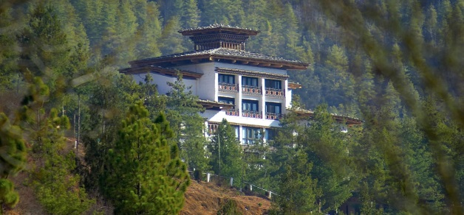

Uma Paro

Effective: 27.05.15

Ref: PH-C-0001-KQ

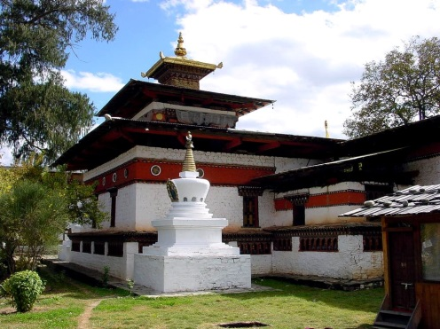

Kyichu Lhkhang

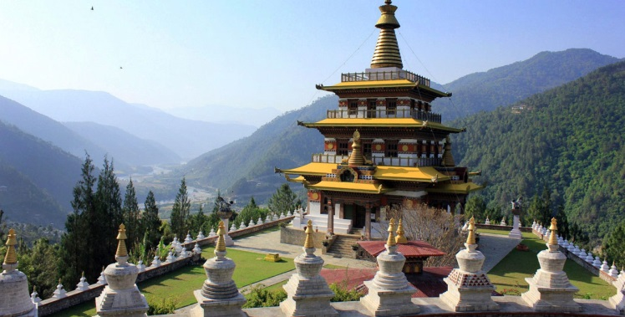

Dungtse Lhakhang

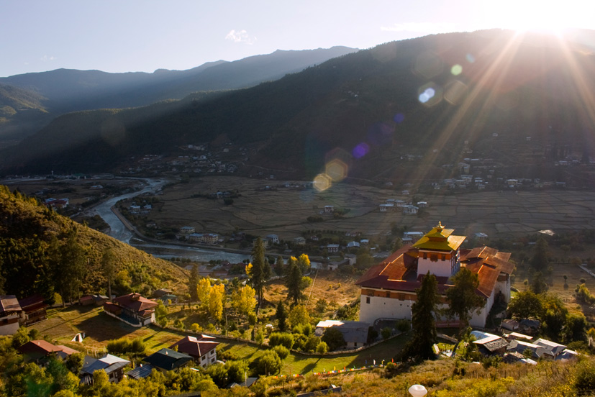

Paro valley

|  |  |
| --- | --- |
| Date日期 | Itinerary行程 |
| Day 5  第五天 | Punakha普那卡 → Paro 乘車至帕羅  Early morning hike to Khamsum Yuelley Namgyal Temple → Chimi Lhakhang (Fertility Temple of Divine Madman) → drive approximately 4 hours to Paro. Overnight in Uma Paro.  Accommodation : Uma by COMO Paro (Category A)  Meal: Breakfast + Lunch + Dinner |
| Day 6  第六天 | Paro帕羅  After breakfast, hike to Taktsang Monastery 虎穴寺 (tiger’s lair / nest) → Drukgyel Dzong (commemorate Bhutan’s victory over the Tibetans) → Rinpung Dzong (fortress of a heap of jewels).  Accommodation : Uma by COMO Paro (Category A)  Meal: Breakfast + Lunch + Dinner |
| Day 7  第七天 | Paro帕羅 → Bangkok曼谷 → Hong Kong香港  After breakfast, depart Bhutan. The end of Bhutan journey.  Meal: Breakfast |

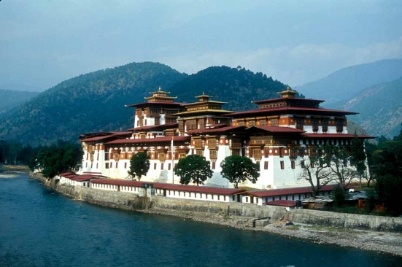

Punakha Dzong

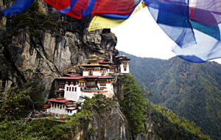

Taktsang Monastery

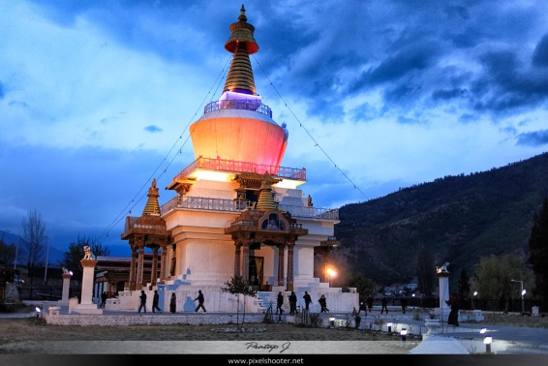

Memorial Chorten

**Package Price:**



|  |  |
| --- | --- |
| Basic Package Price (Min. 2 people travel together) | HK$39,188 per person |

|  |  |
| --- | --- |
| **Package Prices Include:**  * Roundtrip economy class air ticket between Hong Kong and Bangkok by Hong Kong Airlines (HX).  * Roundtrip economy class air ticket between Bangkok and Paro by Bhutan Airlines (B3).  * Hotel accommodation & meals as mentioned.  * English speaking local guide in Bhutan and transfer during the tours.  * Entrance fee as per the sightseeing tours.  * E-Visa Fee.  * Government tourist tariff.  * 0.15% TIC Levy. | **以上價格包括：**  * 香港航空來回香港至曼谷經濟客位機票。  * 不丹航空來回曼谷至帕羅經濟客位機票。  * 行程提及之酒店住宿及膳食。  * 不丹當地觀光團之專業英語導遊 及 交通接送。  * 觀光團之景點入場費。  * 電子簽證費用。  * 旅遊發展及政府專利稅。  * 0.15% 旅遊業議會印花稅。 |
| **Remarks:**  * All the above fare base on HKD.  * Booking: by PAM Holidays.  * Ticket Validity: 0-3months.  * Price quoted does not include Tour Escort from Hong Kong.  * Minimum 2 passengers (paying adult prices) & all passengers MUST travel and check-in together on the same outbound and inbound flights.  * All the above rate is person and valid on HX+B3 Operating Flights only.  * All is adult fare.  * Packages are non-endorsable, non-reroutable, non-refundable & valid on flight/date shown.  * Prices exclude any applicable taxes & fuel surcharges.  * All rates are subject to weekend and high season fair period surcharge.  * Prices are subject to change without prior notice.  * In case of discrepancy between the English & Chinese versions, the English version shall prevail. | **備註：**  * 以上價格全以港幣結算。  * 訂位：由PAM Holidays代訂。  * 機票有效期: 0-3個月。  * 不包括香港領隊。  * 最少兩人(支付成人價錢)同行﹐所有同行客人之行程﹑航班必須相同﹐並必須於去程及回程時一同辦理登機手續。  * 以上價錢每人計及適用於HX+B3營運航班。  * 不設小童收費。  * 旅遊套餐不得更改航班 / 日期 / 行程及不可退款。  * 以上價格不包括所有有關稅項及燃油附加費。  * 以上價格於週末及旺季期間需繳付額外附加費。  * 價格如有任何變更恕不另行通知。  * 所有英文及中文版本的條款如有任何差異，一概以英文版本為準。 |