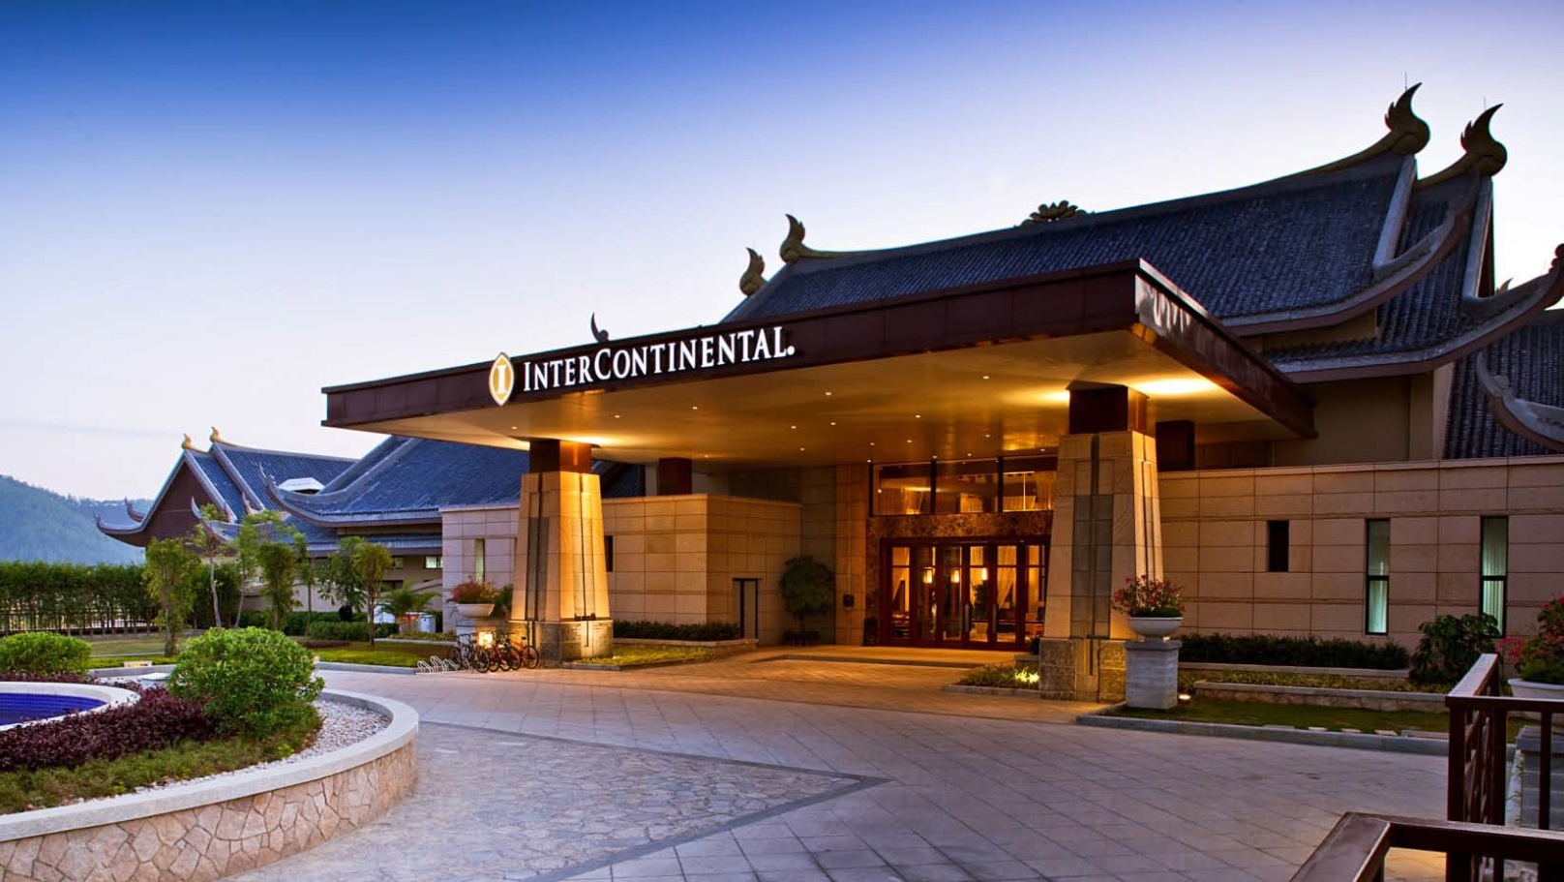

**$920+**

Per room per night

Staying Period: 01Jan-29Dec’19

**夏、冬天免費享用溫泉池**

*注意：高速鐵路售票已實施車票實名制。所有乘客購買車票時，除需提供行程資料（如起點或終點站、列車時間等）外，亦需提供乘客有效身份證明文件上顯示的全名及身份證明號碼

**InterContinental Huizhou Resort**

**《西九高鐵精選》惠州洲際度假酒店**

|  |  |  |
| --- | --- | --- |
| **推薦2日1夜行程（自費活動）** | | |
| 第一天 | 0911 - 1032 | 乘坐由香港出發之G6386列車前往惠州南站 |
| 自由活動 | 遊覽惠州西湖、潮人步行街、梅菜街 |
| 午餐 |
| 1500 | 自行前往酒店辦理入住手續，自由活動及晚餐 |
| 第二天 | 0800 | 享用酒店早餐 |
| 1100 | 酒店辦理退房手續 |
| 自由活動 | 遊覽廣東四大名山（羅浮山風景區）及午餐 |
| 1815 - 1925 | 乘坐由惠州南站之G3007列車返回香港 |
| *推薦行程僅供參考，價格並未包括在酒店內、旅遊保險及惠州南站至酒店交通接送服務，請自行處理 | | |

**自選日期．交通便利．輕鬆出發**

**額外選購:**

**香港至惠州南來回**

**高速鐵路車票**

**另加 $218+**

**(每位 - 二等座)**

|  |  |  |  |  |  |  |  |  |  |  |
| --- | --- | --- | --- | --- | --- | --- | --- | --- | --- | --- |
| 列車行車時間表 Train Schedule  由香港西九龍出發 From Hong Kong West Kowloon | | | | |  | 列車行車時間表 Train Schedule  由惠州南出發 From Huizhounan | | | | |
| 車次  Train | 起點  From | 終點  To | 出發時間  Departure | 到達時間  Arrival |  | 車次  Train | 起點  From | 終點  To | 出發時間  Departure | 到達時間  Arrival |
| G6382 | 香港西九龍  Hong Kong West Kowloon | 惠州南  Huizhounan | 0723 | 0830 |  | G3003 | 惠州南  Huizhounan | 香港西九龍  Hong Kong West Kowloon | 1335 | 1451 |
| G3006 | 0840 | 0950 |  | G6385 | 1430 | 1553 |
| G6386 | 0911 | 1032 |  | G3007 | 1815 | 1925 |
| G3004 | 1518 | 1624 |  | G3005 | 2034 | 2142 |
| G3008 | 1947 | 2053 |  | G6387 | 2138 | 2255 |
| ※此時間表只供參考。以購票時系統顯示為準  ※This timetable is for reference only. Please refer to the timetable shown on ticketing system for the most updated train schedule | | | | | | | | | | |

|  |  |  |  |  |  |
| --- | --- | --- | --- | --- | --- |
| 房間類型  Room Type | 入住日期  Staying Period | 早餐BF | 每房每晚 Price per room per night | | |
| 周日至周四**Sun-Thu** | 周五  **Fri** | 周六  **Sat** |
| 行政客房Club Room (56 sq.m) | 01-31Jan’19,  01-29Dec’19 | **✓** | $1,160 | $1,280 | $1,520 |
| 01Feb’19-31Mar’19,  01-30Nov’19 | $1,100 | $1,220 | $1,460 |
| 01-30Apr’19,  01-31Oct’19 | $1,000 | $1,120 | $1,360 |
| 01May-30Sep’19 | **$920** | $1,040 | $1,280 |
| 水療客房SPA Studio (65 sq.m) | 01-31Jan’19,  01-29Dec’19 | **✓** | $1,520 | $1,640 | $1,880 |
| 01Feb’19-31Mar’19,  01-30Nov’19 | $1,460 | $1,580 | $1,820 |
| 01-30Apr’19,  01-31Oct’19 | $1,360 | $1,480 | $1,720 |
| 01May-30Sep’19 | $1,280 | $1,400 | $1,640 |
| 行政客房附溫泉池  Club Room with Hot Spring Pool  (56 sq.m) | 01-31Jan’19,  01-29Dec’19 | **✓** | $1,880 | $2,000 | $2,240 |
| 01Feb’19-31Mar’19,  01-30Nov’19 | $1,820 | $1,940 | $2,180 |
| 01-30Apr’19,  01-31Oct’19 | $1,720 | $1,840 | $2,080 |
| 01May-30Sep’19 | $1,640 | $1,760 | $2,000 |
| ※ 加床收費：$700 (每位每晚) // Charge of extra bed: $700 per person per night  *價格不適用於香港及中國公衆假期 | | | | | |

|  |  |
| --- | --- |
| **Package Prices Include:**  * 1 night hotel accommodation with 2 breakfast  * Free use of hot spring pool  * Free Wi-Fi in hotel  * Free admission to Kid’s Club | **以上價格包括：**  * 1晚住宿連兩份早餐  * 免費享用溫泉池 * 酒店內無線網絡服務 * 兒童俱樂部安排各種不同活動 |
| **Remarks:**  * All prices are based on HKD  * Hotel stay must be completed on or before 29Dec18 (except specified)  * Hotel prices and conditions are subject to change for non-consecutive stay  * All prices are subject to high season, Hong Kong and China public holidays surcharge  * All payment made are non-refundable  * For reservation made without 7 days prior to check-in, full payment is required within 2 days after reservation  * Full payment is required for booking made within 7 days prior to check-in  * Information on this flyer are subject to change | **備註：**  * 以上價格全以港幣計算  * 酒店住宿必須於19年12月29日或之前完成 (特別註明除外)  * 如只預訂房間或作不連續住宿，酒店價目及條款或會有所調整及變動  * 以上價格於旺季、香港及中國公衆假期期間需繳付額外附加費  * 訂房作實後兩天內須繳付全部費用  * 預定7天內入住之房間，必須先收取全費，方進行預定  * 已繳款項不設退款  * 資料及圖片僅供參考，如有任何變更恕不另行通知 |