Agency / Tour Operator Activity
- Tour programs
Agency advertising
    - Goldjoy
- 20170406_HKET
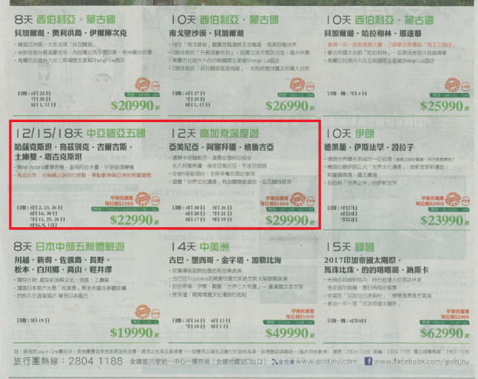
- 20170413_Newsletter
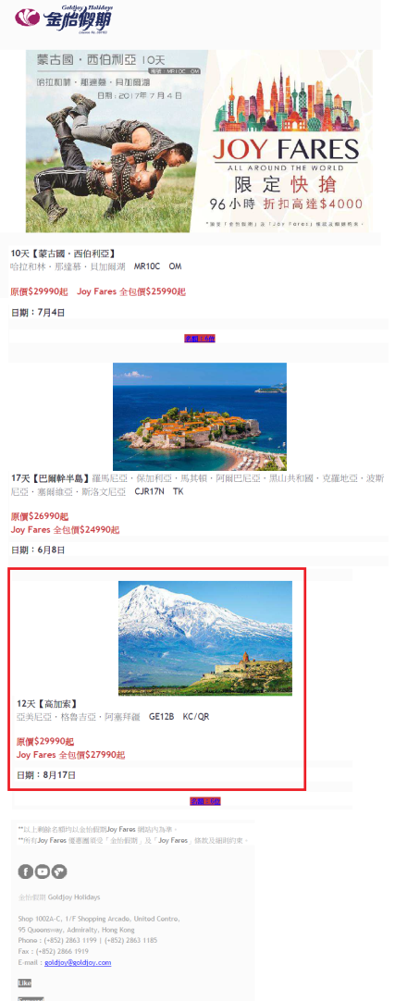

    - Sunflower
- 20170409_Apple Daily | - 20170409_Oriental Daily
- 20170416_Apple Daily | - 20170416_Oriental Daily

  - Competitor Activity
- Tour agency use other airlines for their tour
Istanbul tour
- Sunflower (By TK)
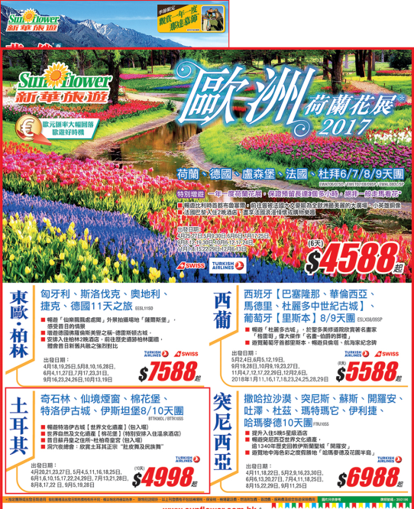
Iran tour
- HKET (By QR)
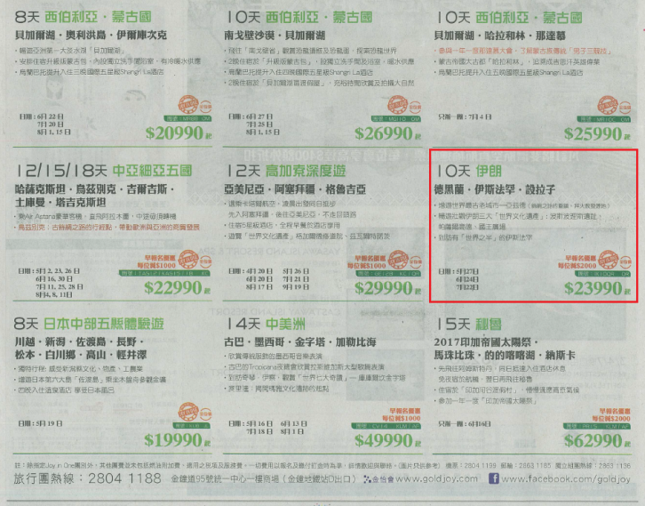

- Promotion fare
- VN promotion fare to Russia
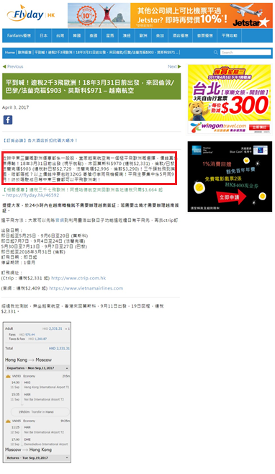

- QR promotion fare to Europe
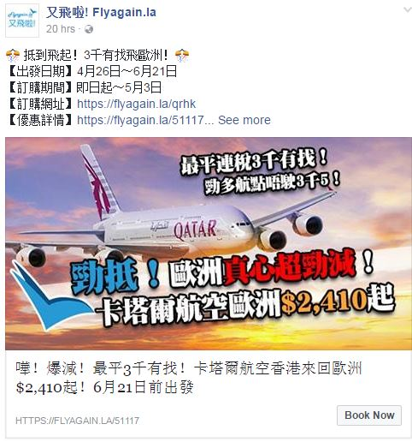

Marketing Activity
Social Network marketing
- 20170407_ITE Facebook
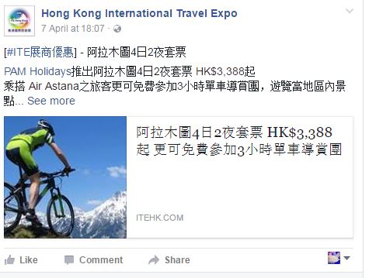
E-news
- 20170412_ITE EDM
