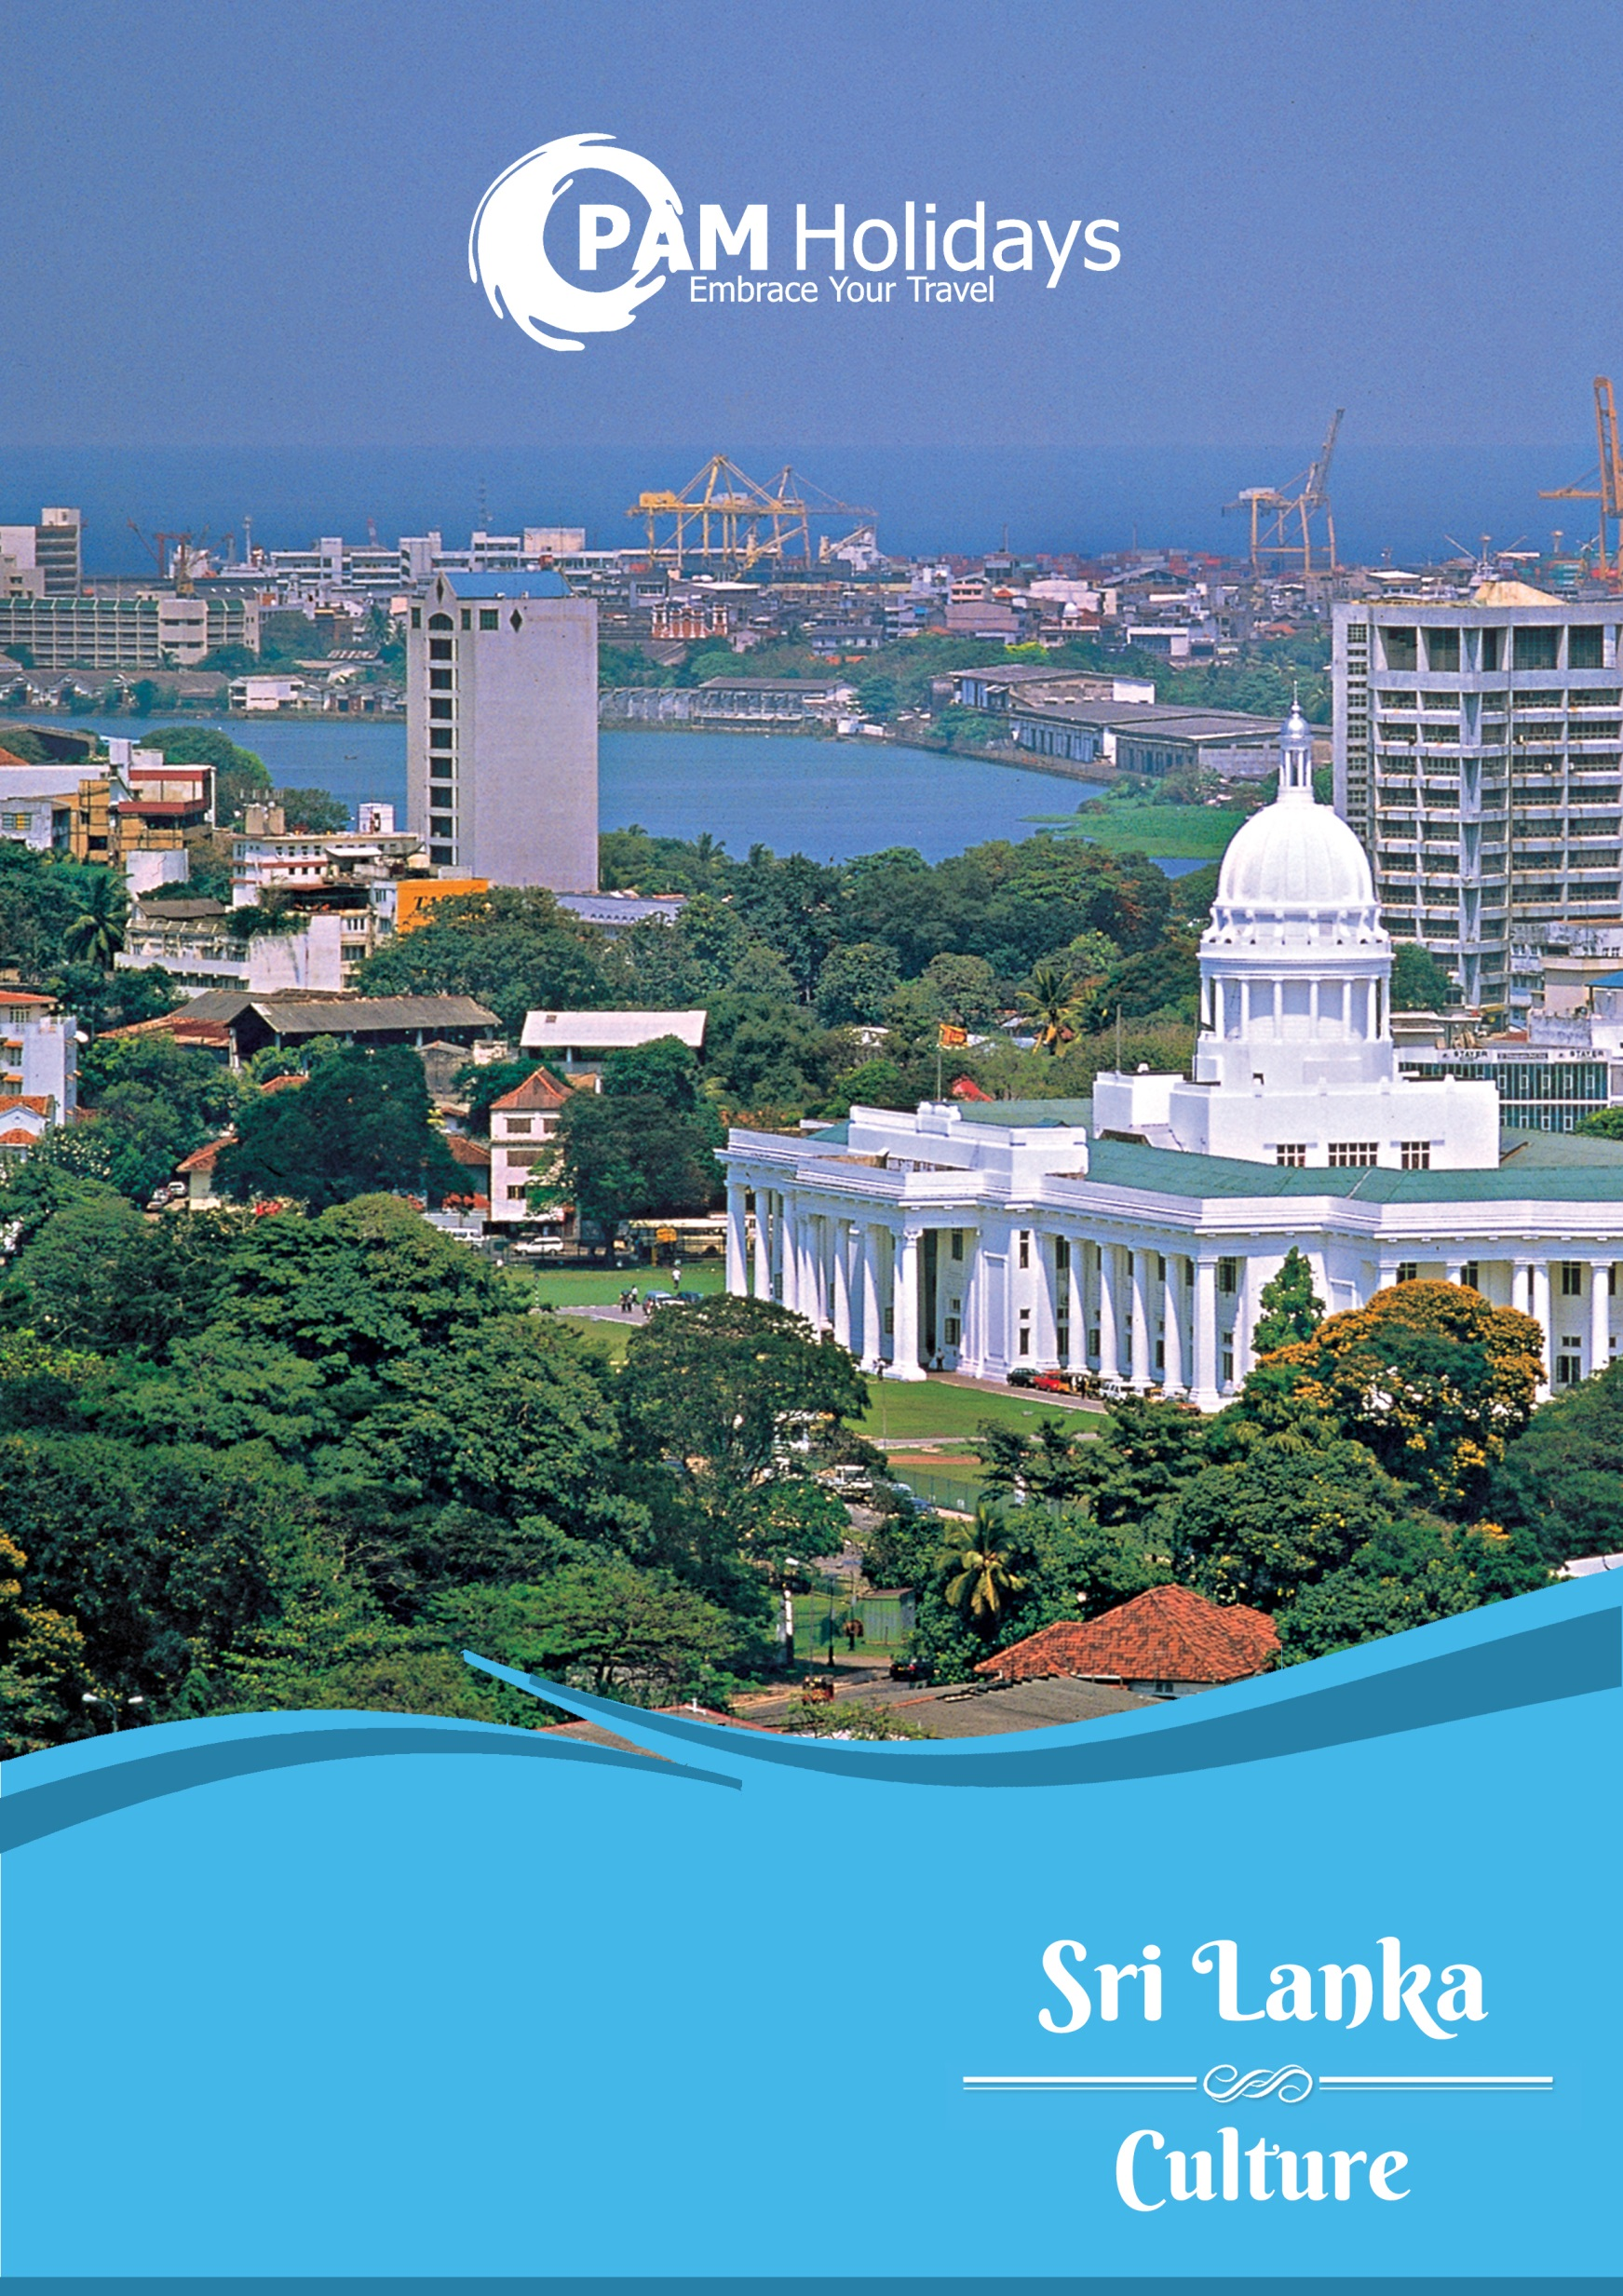

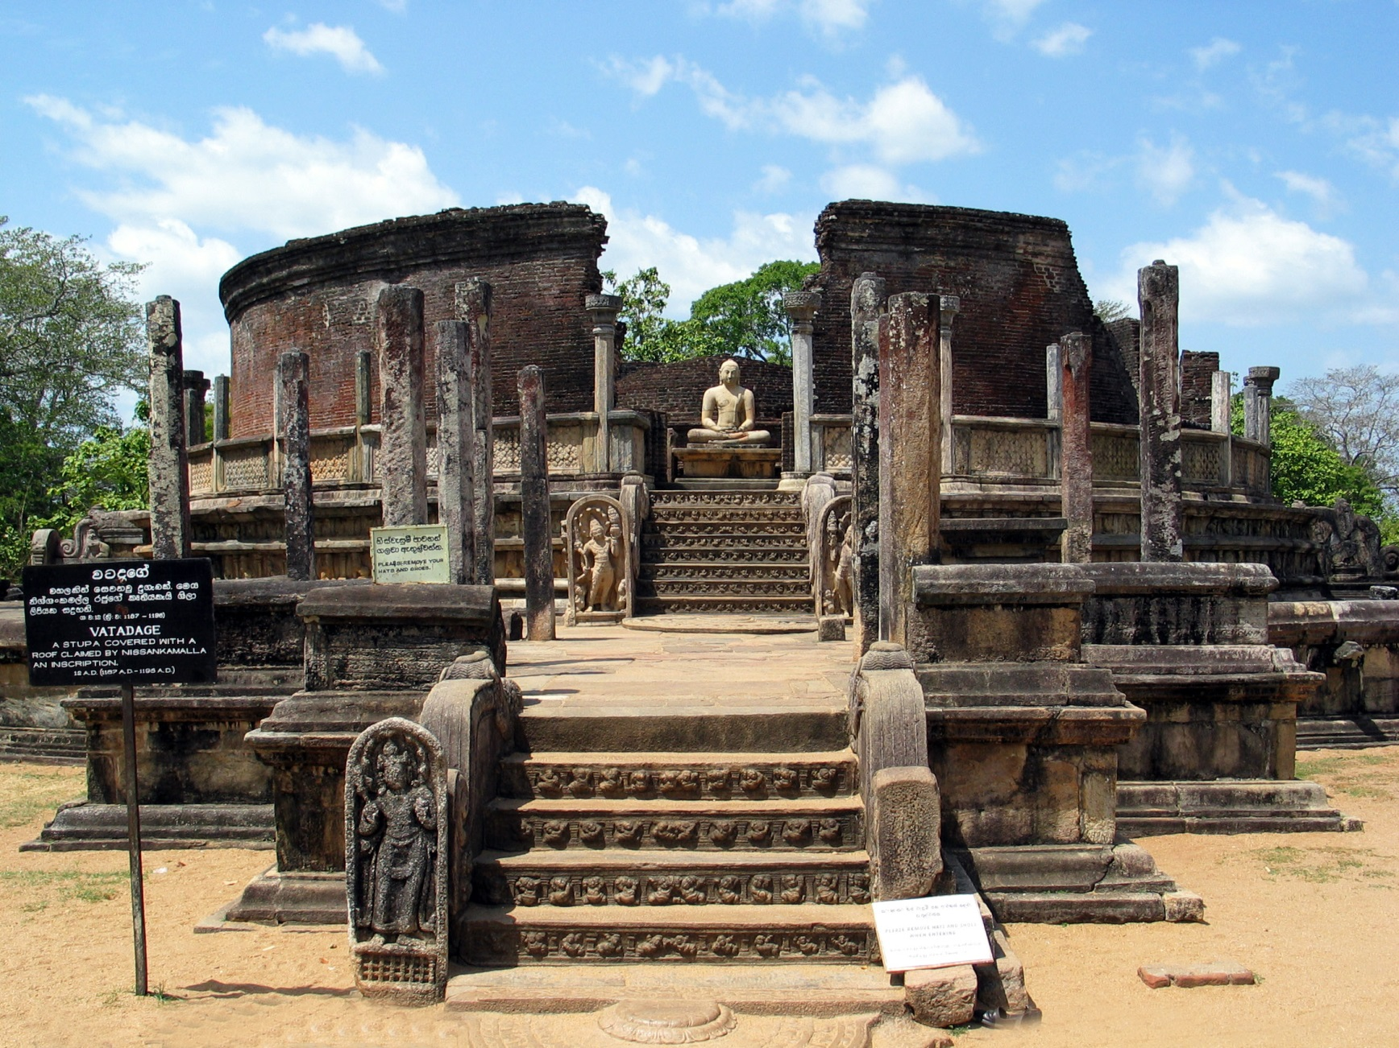

**$5,280+**

Price valid until 31Oct’19

Blackout dates: 03-10Feb’19

**Sri Lanka 6 Days 4 Nights Package**

**斯里蘭卡6日 4夜套票**

**Basic Information:**



|  |  |
| --- | --- |
| Weather:  氣溫: | Average 25°C  平均25°C |
| Season:  氣候: | Hot and rainy throughout the year  全年氣候炎熱及多雨 |
| Time Difference:  時差: | 2.5 hours behind of Hong Kong  比香港慢2.5小時 |
| Distance from HK:  與香港相距 | Approx. 4,050 km  約4,050公里 |
| Flight Duration:  航班飛行時間: | Approx. 7 hours 45 minutes  (Exclude transit time)  約7小時45分鐘(不包括轉機時間) |
| Visa:  簽證: | Required for HKSAR and BNO passport holder  An Electronic Travel Authorization (ETA) must be obtained before departure  特區護照及英國國民(海外)護照 持有人均須簽證  所有入境旅客於出發前需辦理電子簽證(ETA)  [Details 詳情](http://www.immigrationlanka.com/Home-0.html) |

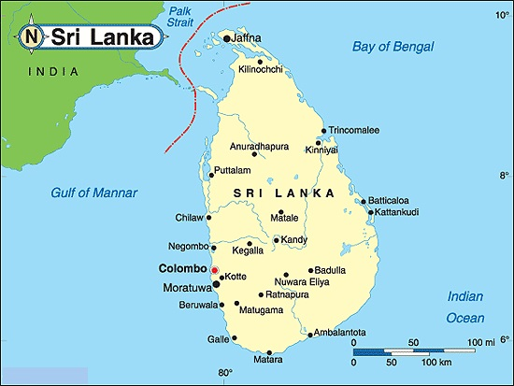

|  |  |  |  |  |
| --- | --- | --- | --- | --- |
| Date  日期 | Itinerary for 6 Days  6天行程 | Meals 餐食 | | |
| B | L | D |
| Day 1  第一天 | Hong Kong香港 (經吉隆坡) 🡺 Negombo內貢博   * Arrival Colombo, Sri Lanka by Malindo Air * Meet and greet at airport and proceed to Negombo   Accommodation: Standard Plan – [GSH Colombo](https://greatsouthernhotel.com.au/great-southern-hotel-colombo/) (3*) | - | - | - |
| Day 2  第二天 | Negombo內貢博 🡺 Dambulla丹布勒 🡺 Sigiriya 錫吉里耶   * Dambulla Rock Temple houses some of the most unique deawings in magnificently constructed 5 cave temples flanking the golden temple of Dambulla. * Sigiriya Rock (Optional: HKD280 per person) – The 5th century rock citadel of King Kasyapa and World Heritage Site   Accommodation: Standard Plan – [Palwehera Resort](https://palweheravillageresort.directbookingengine.com/) (3*) | ✓ | ✓ | ✓ |
| Day 3  第三天 | Dambulla丹布勒 🡺 Kandy 康提 🡺 Matale   * Proceed to Kandy. En roue visit a Spice Garden in Matale - An agricultural zone in the Central Province, Matale seldom drops off the maps due to its remarkable contribution through flagship crops of the island extending from tea, rubber & vegetables to spices * City tour of Kandy - the World Heritage Site & last royal capital of Sri Lankan kings - crafts an array of culture, history and heritage in the minds of visitors across the globe. Experience an ancient Kandyan legacy engraved around its crown jewel, the temple of the sacred tooth relic of Lord Buddha   Accommodation: Standard Plan – [Senani Hotel](https://www.oakrayhotels.com/senani-hotel/) or [Kandy City Hotel](http://www.kandycityhotel.lk/) (3*)  ※Video Camera and Still Camera permits at the Temple of the Tooth Relic in Kandy | ✓ | ✓ | ✓ |
| *Accommodation: If the mentioned of above are full, the same grading hotel will be provided. | | | | |

|  |  |  |  |  |  |
| --- | --- | --- | --- | --- | --- |
| Package Plan  套票類別 | | Staying Period  入住日期 | Fare per person 每位收費 | | |
| 2 Persons travel together  二人同行 | 4 Persons travel together  四人同行 | 6 Persons travel together  六人同行 |
| Standard Plan | | 15Jan-28Feb | $6,150+ | $5,740+ | $5,590+ |
| 01Mar-30Jun | $5,840+ | $5,420+ | **$5,280+** |
| 01Jul-31Aug | $6,150+ | $5,740+ | $5,590+ |
| 01Sep-31Oct | $5,840+ | $5,420+ | **$5,280+** |
|  | Blackout date: 03-10Feb’19, please contact us for more details | | | | |
|  | The above package price quoted excludes tip & portage. | | | | |

|  |  |  |  |
| --- | --- | --- | --- |
| Frequency 班次 | Flight 航班 | From 由 / To 至 | Dep 起飛 / Arr 到達 |
| Daily | OD606 | Hong Kong香港 / Kuala Lumpur吉隆坡 | 1510 / 1910 |
| OD185 | Kuala Lumpur吉隆坡 / Colombo 可倫坡 | 2215 / 2310 |
| OD186 | Colombo 可倫坡 / Kuala Lumpur吉隆坡 | 0010 / 0630 |
| OD605 | Kuala Lumpur吉隆坡 / Hong Kong香港 | 1010 / 1410 |

*Flight schedules are subject to change without prior notice

*High season surcharge should be applied

**Package Price:**



**Flight Information:**



|  |  |  |  |  |
| --- | --- | --- | --- | --- |
| Date  日期 | Itinerary for 6 Days  6天行程 | Meals 餐食 | | |
| B | L | D |
| Day 4  第四天 | **Kandy康提 🡺 Nuwara Eliya**   * Leave for Nuwara Eliya. En route visit Tea Plantation Sri Lanka, Tea and Tourism are words which cannot be separated. Take a tour to the cold & misty hills that take pride of an ultimate tea tour, covering lush green blankets of tea plantations (Optional: Scenic Train journey from Kandy to Nurwara Eilya HKD240 per person) * City Tour of Nuwara Eliya - Augmented by an English countryside atmosphere, the city of light - once governed by English & Scottish planters - is still studded with colonial bungalows, hedgerows & one of the finest 18-hole golf courses in the world   Accommodation: Standard Plan - [Oak Ray Summer Hill Breeze](https://www.oakrayhotels.com/oak-ray-summer-hill-breeze-nuwara-eliya/) (3*) | ✓ | ✓ | ✓ |
| Day 5  第五天 | **Nuwara Eliya 🡺 Colombo 可倫坡**   * City Tour of Colombo * Furnished today with lavish clothing, food & tea boutiques. ride to Pettah & tune into the Floating Market - an offbeat shopping experience - or feel the buzz surrounding the upcoming inspiration, the Colombo Port City - an offshore city - featuring parks, commercial complexes & even an F1 track. Head along Bauddhaloka Mawatha towards 'Arcade' facing a historic way post, the Independence Square * Transfer to the Airport at late evening | ✓ | ✓ | ✓ |
| Day 6  第六天 | Flight arrives Hong Kong via Kuala Lumpur by | - | - | - |
| *Accommodation: If the mentioned of above are full, the same grading hotel will be provided. | | | | |



|  |  |
| --- | --- |
| **Package Prices Include:**  * Roundtrip economy class air ticket between Hong Kong and Colombo (via Kuala Lumpur) by Malindo Air (OD)  * 4 nights accommodation  * Meals as per the itinerary  * Transportation as per the itinerary  * English speaking local guide and transfer during the tours (Not include tips for local guide and driver, approx. USD8-10 per person per day)  * Entrance fees only include Dambulla Temple, Cultural Show, Kandy Temple  * Hong Kong 0.15% T.I.C. levy | **以上價格包括：**  * 馬印航空來回香港至可倫坡(經吉隆坡)經濟客位機票  * 4 晚酒店住宿  * 行程提及之膳食  * 機場接送及行程內之接載  *當地觀光團連英語導遊及交通接送 (不包括導遊及司機小費，每位每日約USD8-10)  * 入場費包括Dambulla Temple, Cultural Show, Kandy Temple  * 0.15% 旅遊業議會印花稅 |
| **Remarks:**  * All the above fare base on HKD  * Package valid for travel till 31Oct19  * Price quoted does not include Tour Escort from Hong Kong  * All is adult fare  * Ticket is valid for 6 months  * Valid on OD Operating Flights only  * Hotel rates and conditions are subject to change for non-consecutive stay  * All rates are subject to weekend and high season fair period surcharge  * Please make sure there are at least 6 months validity for all travel documents or Visa  * No amendment, cancellation and refund is allowed once documents are issued  * Prices exclude any applicable taxes & surcharges  * Full pay must be received within 2 days upon confirmation. Otherwise booking will be cancelled automatically  * Full payment must be collected if the reservation made within 1 month  * The sequence of the tour, hotel accommodations and sites arrangement may be amended due to circumstances  * Prices are subject to change without prior notice  * Information and images are for reference only | **備註：**  * 以上價格全以港幣結算  * 套票有限期至2019年10月31日  * 不包括香港領隊  * 不設小童優惠  * 機票有效期為6個月  * 適用於馬印航空OD營運航班  * 如只預訂房間或作不連續住宿，酒店價目及條款或會有所調整及變動  * 以上價格於週末及旺季期間需繳付額外附加費  * 請持有效簽証及最少六個月以上有效期之護照入境  * 機票及酒店套票發出後，將不接受更改，取消及退款  * 以上價格不包括所有有關稅項及附加費  * 航班或酒店作實後兩天內須繳付全部費用, 否則自動取消  * 如預定1個月內出發之套票，必須先收取套票全費，方進行預定  * 行程次序安排、酒店住宿及景點安排或會依據當地情況作更改  * 價格如有任何變更恕不另行通知  * 資料及圖片僅供參考 |