07:30AM
弘大鐵路站8號出口
明洞樂天酒店
百玩地公園
08:00AM
10:15AM
Period - 1 : 18_{th} ~ 20_{th} Dec 2019 (KRW 470,000 PER PAX)
Period - 2 : 22_{nd} ~ 24_{th} Dec 2019 (KRW 532,000 PER PAX)
Period - 3 : 25_{th} ~ 27_{th} Dec 2019 (KRW 537,000 PER PAX)

- 首爾 – VIVALDI PARK (提供穿梭巴士)
- 登記房間 (Family Type)
- 韓服體驗
- 洪川郡一天遊 (Suta Temple, 採摘草莓, 享受韓國街邊小食)
- 晚餐 (韓式辣炒雞)
- Snowyland (晚間活動)
- 韓式外帶送上房間 (啤酒 + 韓式炸雞)
- 早餐 – (自助餐)
- 小組滑雪課 (十人一組)
- Ski World (自由時間)
- 晚餐 (自助餐)
- 韓國特色表演
- 早餐 – (自助餐)
- VIVALDI PARK自由時間*
- 小法國村
- 南怡島
- 南怡島 – 首爾 (提供穿梭巴士)
*
VIVALDI PARK提供各設施優惠門票

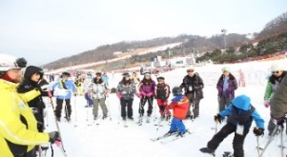
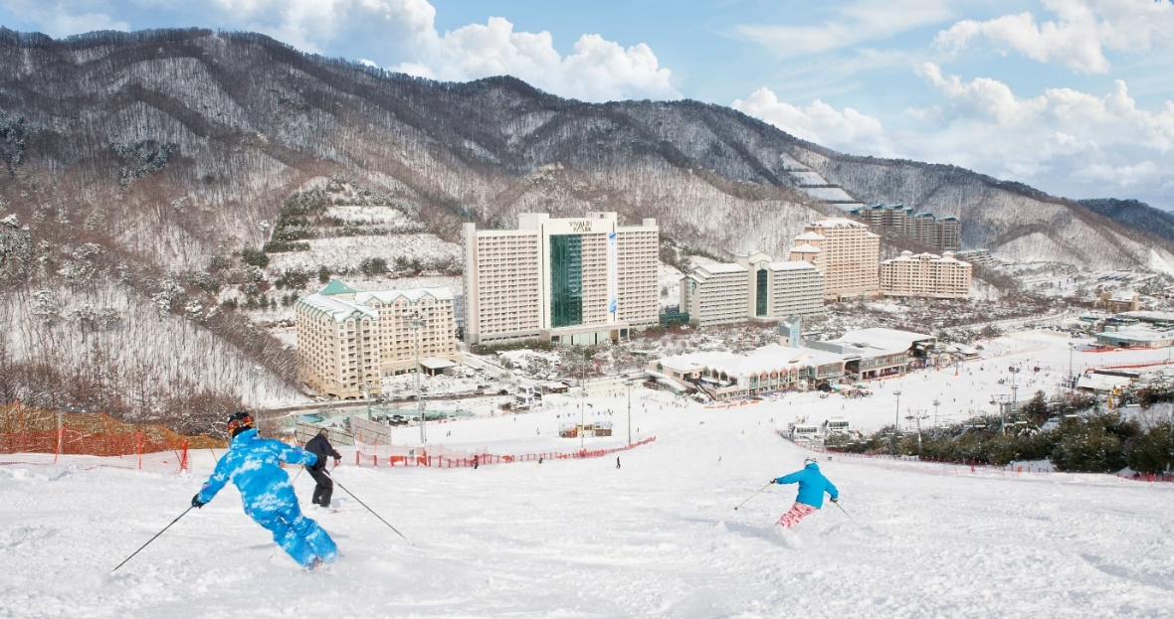
楊平郡大明渡假村
百玩地公園
07:20AM (D)
08:00 (A)
17:40 (D)
18:20PM (A)
楊平郡大明渡假村
KRW 193,000 PER PAX
1st DEC 2019 ~ 29th FEB 2020
- 楊平郡大明渡假村 (Daemyung Resort Yangpyeong)一晚住宿 [Room type : Family]
- 免費穿梭巴士來往 (楊平郡大明渡假村 – 百玩地公園)
- 滑雪纜車門票 & 租用滑雪用具 (一人) [New morning pass: 10:30 - 17:00]
*[不包含頭盔, 手套, 雪鏡和餐飲]
- 兩小時1對5滑雪課堂 (Basic Morning time lesson)

Step 1: Shuttles to Vivaldi Park
- 先在楊平郡大明渡假村登記>乘坐穿梭巴士前往百玩地公園
Step 2: Ticket issuing for SKI WORLD
- 到達後前往滑雪中心
- 請準備預訂套票資料到滑雪中心的票務部
- 旅客會收到滑雪纜車門票 + 租借滑雪用具票 & 租借雪衣雪褲票
* 屆時徵收每人KRW 2,000的LIFT RFID Card 租借費用
*活動完結後，請歸還LIFT RFID Card到票務部
Step 3: SKI suit rental
- 請準備租借雪衣雪褲票
- 在房間內換好雪衣雪褲的裝備
- 換穿雪鞋把鞋子放入置物櫃 (租用置物櫃費用KRW 2,000)
Step 4: SKI Equipment rental
- 請準備租借滑雪用具票
- 職員會為你安排用具
Step 5: SKI Lesson
- 穿好裝備後, 請在09:30前到旅客中心集合 (Tourist center)
* 兩小時課程 (五人為一組和一位教練)
Step 6: Return
- 請在離開前歸還所有租借滑雪用具, 雪衣和雪褲及LIFT RFID Card
Step 7: Back to Yangpyeong Resort!
- 請17:30前在車站等候，穿梭巴士會接載回到楊平郡大明渡假村

※所有票務，租賃流程和場地可能會在事先通知的情況下作出更改。

Information | Details
Terms & Policy | - If cancelled 45 days or earlier prior to the date of arrival, 0% of total amount will be charged.  - If cancelled between 44 days and 31 days prior to the date of arrival, 25% of total amount will be charged.  - If cancelled between 30 days to 15 days prior to the date of arrival, 50% of total amount will be charged.  - If cancelled 14 days or later prior to the date of arrival, 100% of total amount will be charged.
Notice | - Place and time for the ski lesson are subject to change with notice in advance.  - Helmet, Gloves, Goggles and Meal are not included in this package.  - The same price applies for adult and children. Voucher will be issued via e-mail.  - Please present either a printed voucher or reservation number through mobile at ticket office.  - This Package is for Foreigners ONLY.  - Tour starts from minimum 2 persons.  - Rates, availability, cancellation policy & conditions are based on Daemyung B2B system indicated.
Daemyung (GSA: Falcon Marketing Limited)
Tel: (852) 3678 2031
Fax: (852) 21873443
E-mail: pamholidays@pam.com.hk

If you don’t have B2B login, please download and fill in the registration form and send it back to us!

