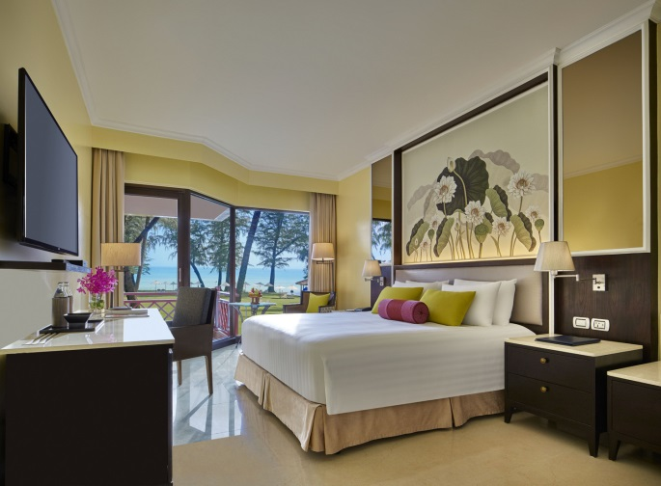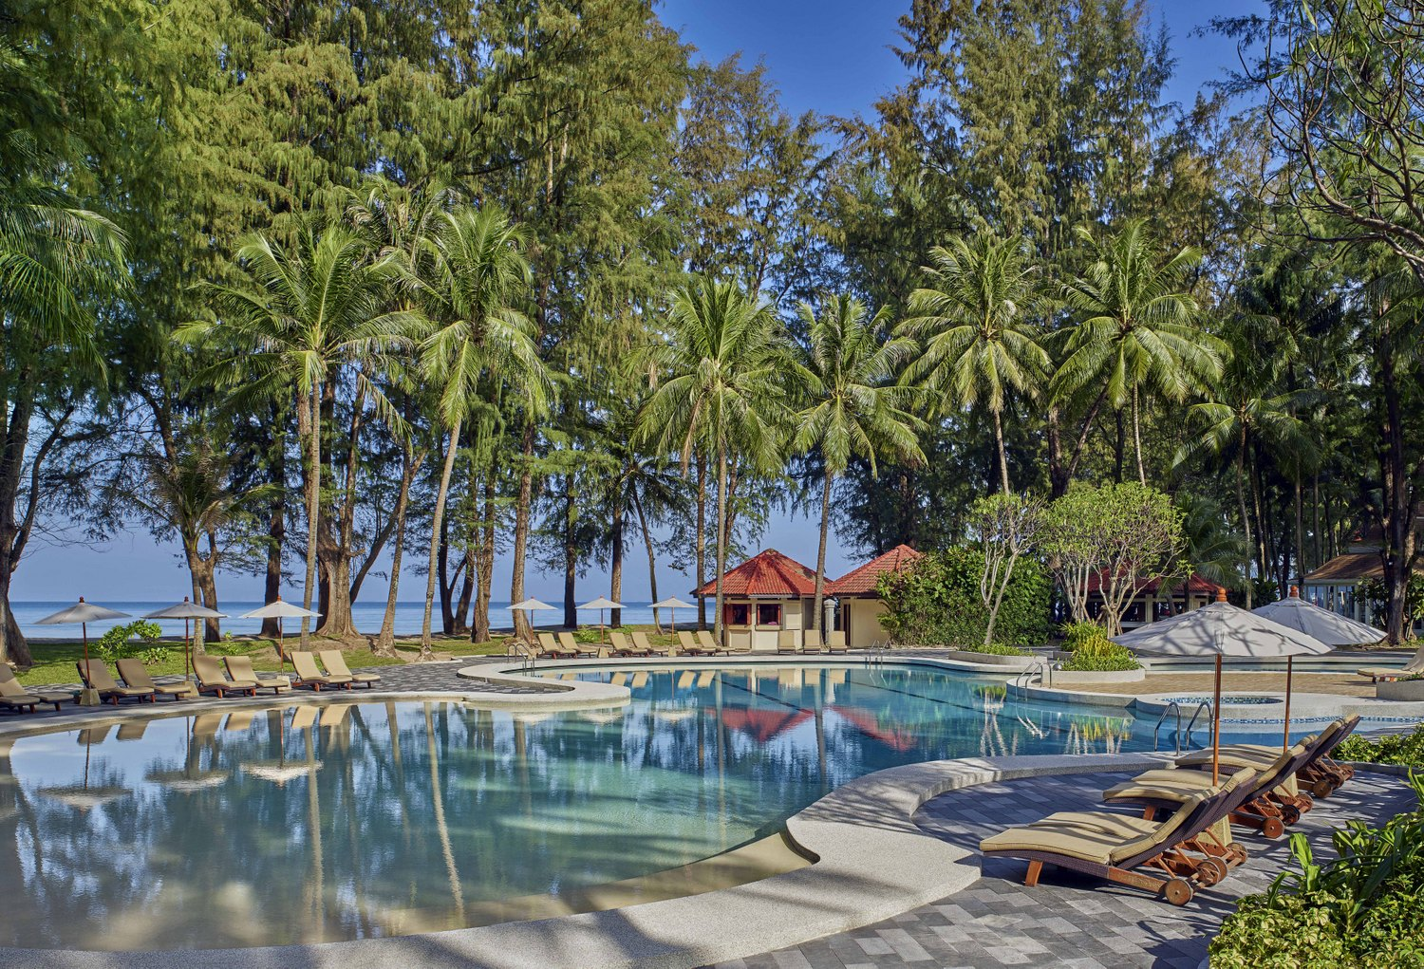

**Phuket Dusit Thani Laguna 3 Days 2 Nights Package**

**布吉Dusit Thani Laguna 3日2夜套票**

**Basic Information:**



**$4,200+**

Sales period: 16-31 Jan 2019

Stay Period: 16Jan-31Mar 2019

|  |  |
| --- | --- |
| Weather:  氣溫: | Average 28°C  平均28°C |
| Season:  氣候: | Hot and rainy throughout the year  全年氣候炎熱及多雨 |
| Time Difference:  時差: | -1 hour |
| Distance from HK:  與香港相距 | Approx. 2,328 km  約2,328公里 |
| Flight Duration:  航班飛行時間: | Approx. 3 hours 30 minutes  約3小時30分鐘 |
| Visa:  簽證: | Visa free for HKSAR and BNO passport holder  特區護照 及 英國國民(海外)護照 持有人毋須簽證 |

|  |  |  |  |
| --- | --- | --- | --- |
| Frequency 班次 | Flight 航班 | From 由 / To 至 | Dep 起飛 / Arr 到達 |
| Daily | WE609 | Hong Kong香港 / Phuket 布吉 | 10:25 / 12:55 |
| WE608 | Phuket 布吉 / Hong Kong香港 | 15:40 / 20:05 |

*Flight schedule are subject to change without prior notice

*Airfare surcharge will be applied during Chinese New Year period

**Flight Information:**



**Price List:**



|  |  |  |  |  |  |  |
| --- | --- | --- | --- | --- | --- | --- |
| Room Type  房間類型 | Staying Period  入住日期 | BF  早餐 | Price per person 每位收費 | | Extension Night 續住房間  (per room per night每房每晚) | |
| Twin Share  雙人房 | Single  單人房 | Twin Share  雙人房 | Single  單人房 |
| Deluxe Lagoon View | 16Jan-04Feb’19 | ✓ | **$4,200+** | $6,190+ | $1,940 | $1,940 |
| 05-10Feb’19 | $4,620+ | $6,990+ | $2,350 | $2,350 |
| 11Feb-31Mar’19 | **$4,200+** | $6,200+ | $1,940 | $1,940 |
| Deluxe Sea View | 16Jan-04Feb’19 | $4,350+ | $6,480+ | $2,080 | $2,080 |
| 05-10Feb’19 | $4,750+ | $7,280+ | $2,480 | $2,480 |
| 11Feb-31Mar’19 | $4,350+ | $6,480+ | $2,080 | $2,080 |
| Deluxe Ocean Front | 16Jan-04Feb’19 | $4,480+ | $6,750+ | $2,220 | $2,220 |
| 05-10Feb’19 | $4,900+ | $7,550+ | $2,620 | $2,620 |
| 11Feb-31Mar’19 | $4,480+ | $6,750+ | $2,220 | $2,220 |
| Laguna Pool Villa  2-Bedroom (4 Pax) | 16Jan-04Feb’19 | $4,880+ | - | $5,270 | - |
| 05-10Feb’19 | $5,080+ | - | $5,580 | - |
| 11Feb-31Mar’19 | $4,880+ | - | $5,270 | - |

|  |  |
| --- | --- |
| **Package Prices Include:**  * Roundtrip economy class air ticket between Hong Kong and Phuket by Thai Smile (WE)  * 2 nights’ accommodation  * Hong Kong 0.15% T.I.C. levy | **以上價格包括：**  *泰國微笑航空來回香港至布吉經濟客位機票  * 2晚酒店住宿  * 0.15% 旅遊業議會印花稅 |
| **Remarks:**  * All prices are in HK dollar  * Booking class: By PAM Holidays  * Package valid for travel till 31Mar19  * All is adult fare  * Valid on Thai Smile (WE) operating flights only  * Minimum 2 passengers (paying adult prices) & all passengers MUST travel and check-in together on the same outbound and inbound flights.  * Hotel rates and conditions are subject to change for non-consecutive stay  * All rates are subject to weekend and high season fair period surcharge  * Please make sure there are at least 6 months validity for all travel documents or Visa  * No amendment, cancellation and refund is allowed once documents are issued  * Prices exclude any applicable taxes & surcharges  * Full pay must be received within 2 days upon confirmation. Otherwise booking will be cancelled automatically  * The sequence of the tour, hotel accommodations and sites arrangement may be amended due to circumstances  * Prices are subject to change without prior notice  * Information and images are for reference only | **備註：**  * 價格以港幣計算  * 訂位代號：由PAM Holidays代訂  * 套票有限期至2019年03月31日  * 不設小童優惠  * 只適用於泰國微笑航空(WE)之營運航班  * 最少兩人(支付成人價錢)同行﹐所有同行客人之行程﹑航班必須相同﹐並必須於去程及回程時一同辦理登機手續。  * 如只預訂房間或作不連續住宿，酒店價目及條款或會有所調整及變動  * 以上價格於週末及旺季期間需繳付額外附加費  * 請持有效簽証及最少六個月以上有效期之護照入境  * 機票及酒店套票發出後，將不接受更改，取消及退款  * 以上價格不包括所有有關稅項及附加費  * 航班或酒店作實後兩天內須繳付全部費用, 否則自動取消  * 行程次序安排、酒店住宿及景點安排或會依據當地情況作更改  * 價格如有任何變更恕不另行通知  * 資料及圖片僅供參考 |

Effective: 27.05.15

Ref: PH-C-0001-KQ