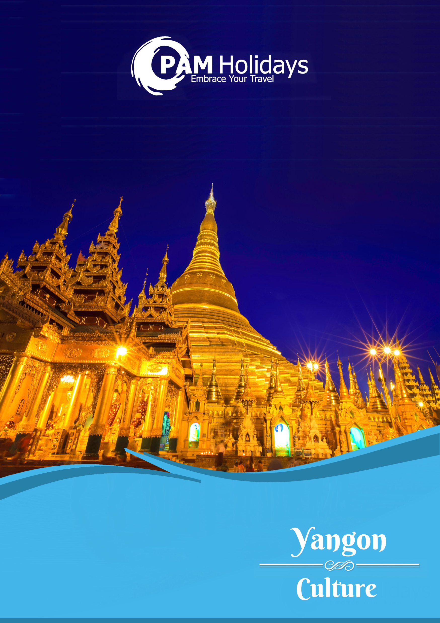

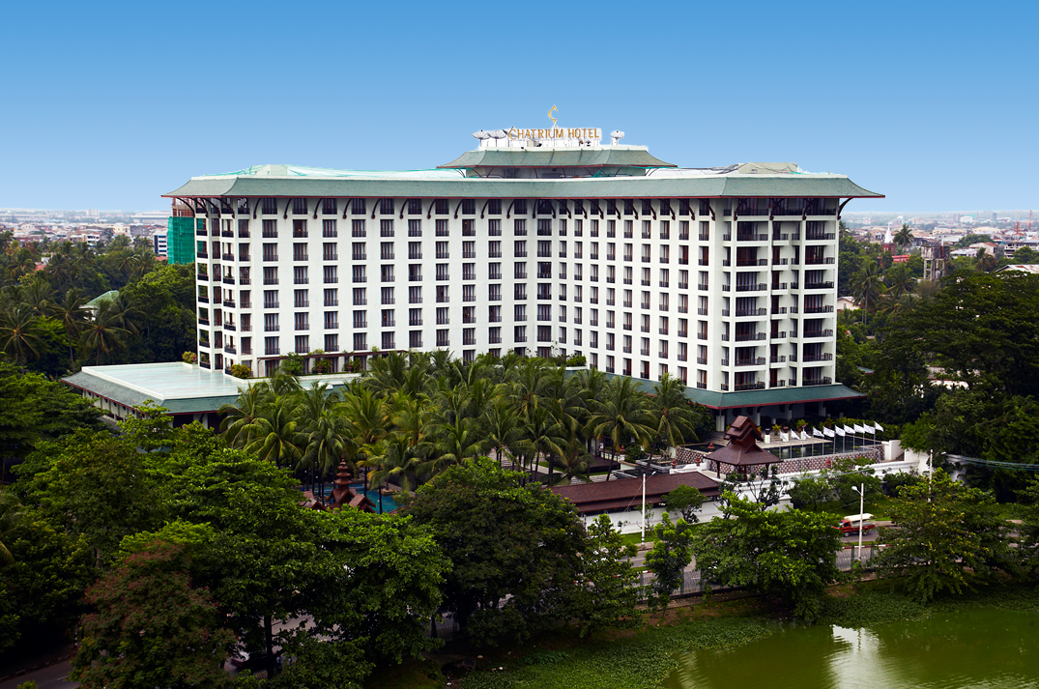

**Chatrium Hotel Royal Lake Yangon**

**2 Nights Package**

**仰光2晚套票 - 察殿仰光皇家湖酒店**

**$2,988+**

Validity: 01May-30Sep17



**Basic Information:**



|  |  |
| --- | --- |
| Weather:  氣溫: | Average: Mar – Apr 30-35°C / May – Oct 25-30°C / Nov – Feb 20-24°C  平均: 3 – 4月30-35°C / 5 – 10月25-30°C / 11– 2月 20-24°C |
| Season:  氣候: | November – February Dry and Cool  11 – 2月 乾燥及清涼 |
| Time Difference:  時差: | -1.5 hours |
| Distance from HK:  與香港相距 | Approx. 1,975 km  約1,975公里 |
| Flight Duration:  航班飛行時間: | Approx. 3 hours  約3小時 |
| Visa:  簽證: | Required需要  [Online application 網上申請](http://evisa.moip.gov.mm/index.aspx)  [More Information 更多資訊](http://hong-kong-economy-research.hktdc.com/business-news/article/%E7%B0%BD%E8%AD%89%E6%98%93/%E7%B7%AC%E7%94%B8-%E7%B0%BD%E8%AD%89%E6%98%93/vod/tc/1/1X000000/1X05UGK4.htm) |

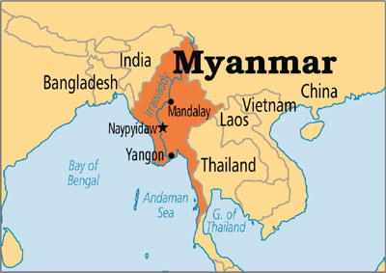

|  |  |  |  |  |
| --- | --- | --- | --- | --- |
| Date 日期 | | Flight 航班 | From 由 / To 至 | Dep 起飛 / Arr 到達 |
| From 26Mar | Mon-Wed, Fri-Sun | CX5250, KA250 | Hong Kong香港 / Yangon仰光 | 2145 / 2330 |
| Thu | CX5252, KA252 | 2250 / 0030 + 1 |
| Mon-Thu, Sat-Sun | CX5251, KA251 | Yangon仰光 / Hong Kong香港 | 0110 / 0545 |
| Fri | 0125 / 0555 |

*Flight schedules are subject to change without prior notice

|  |  |  |  |  |  |  |  |  |
| --- | --- | --- | --- | --- | --- | --- | --- | --- |
| Room Type  房間類型 | Staying Period  入住日期 | BF  早餐 | Price per person 每位收費 | | | Extension Night 續住房間  (per room per night每房每晚) | | |
| Twin Share  雙人房 | Single  單人房 | Extra Bed  加床房 | Twin Share  雙人房 | Single  單人房 | Extra Bed  加床房 |
| Deluxe (ROH)  (Incl. 2 breakfast)  Deluxe Room City View at Chatrium Hotel Royal Lake Yangon | Till 30Sep | ✓ | **$2,988** | $3,788 | $3,088 | $970 | $970 | $620 |
| Lake or Pagoda View  (Incl. 2 breakfast)  http://www.chatrium.com/d/chatrium_hotel_yangon/media/OPTIMIZED_IMAGE/rooms/__thumbs_380_230_crop/Deluxe-Room-Lake-View-3-small_bf39f2.jpg?1449757818 | Till 30Sep | $3,188 | $4,188 | $1,170 | $1,170 |
| Chatrium Club Room (ROH)  (Incl. 2 breakfast)  Club Deluxe Room City View at Chatrium Hotel Royal Lake Yangon | Till 30Sep | $3,188 | $4,288 | $1,210 | $1,210 |
| Corner Deluxe Room  (Incl. 2 breakfast)  Corner Deluxe Room at Chatrium Hotel Royal Lake Yangon | Till 30Sep | $3,788 | $5,488 | $1,790 | $1,790 |

**Flight Information:**



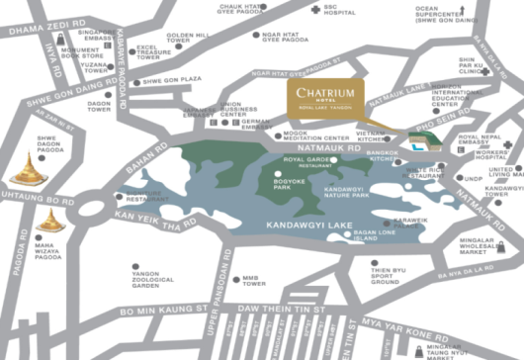

|  |  |
| --- | --- |
| **Package Prices Include:**  * Roundtrip economy class air ticket between Hong Kong and Yangon by Cathay Dragon.  * 2 nights hotel accommodation in Chatrium Hotel Royal Lake Yangon.  * Hong Kong 0.15% T.I.C. levy. | **以上價格包括：**  * 國泰港龍航空來回香港至仰光經濟客位機票。  * 2晚察殿仰光皇家湖酒店住宿。  * 0.15% 旅遊業議會印花稅。 |
| **Remarks:**  * All the above fare base on HKD.  * Booking class: N.  * Ticket validity: 2-7 days.  * Hotel stay must be completed on / before 30Sep17 (except specified).  * Child fare base on adult fare deduct HKD400 per person.  * Valid on KA Operating Flights only.  * Hotel rates and conditions are subject to change for non-consecutive stay and/or reservation(s) on accommodation only.  * All rates are subject to weekend and high season fair period surcharge.  * Packages are non-endorsable, non-reroutable, non-refundable & valid on flight/date shown.  * Prices exclude any applicable taxes & surcharges.  * Full pay must be received within 3 days upon confirmation. Otherwise booking will be automatically cancelled.  * Prices are subject to change without prior notice. | **備註：**  * 以上價格全以港幣結算。  * 訂位代號：N。  * 機票有效期: 2-7日  * 酒店住宿必須於17年9月30日或之前完成 (特別註明除外)。  * 小童收費按成人價每位減收HKD400。  * 適用於KA營運航班。  * 如只預訂房間或作不連續住宿，酒店價目及條款或會有所調整及變動。  * 以上價格於週末及旺季期間需繳付額外附加費。  * 旅遊套餐不得更改航班 / 日期 / 行程及不可退款。  * 以上價格不包括所有有關稅項及附加費。  * 航班或酒店作實後三天內須繳付全部費用, 否則自動取消。  * 價格如有任何變更恕不另行通知。 |

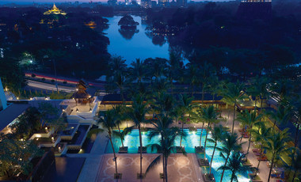

Swimming Pool

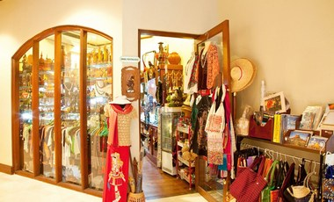

Hotel Kiosk

|  |  |  |  |  |
| --- | --- | --- | --- | --- |
| Ticket Surcharge機票附加費 | | | | |
| Date 日期 | Class (GV2) | Validity | Fare 附加費 (per person每位) | |
| Adult 成人 | Child小童 |
| Till 01May-6Jul, 24Aug-30Sep | S | 2-7 days | $300 | $230 |
| 07Jul-23Aug | V | $1,350 | $1,010 |
| Business Class Ticket Surcharge商務客位機票附加費 | | | | |
| Till 01May-6Jul, 24Aug-30Sep | I | 2-7 days | $3,830 | $2,880 |
| 07Jul-23Aug | 2-14 days | $5,540 | $4,200 |

|  |  |  |  |  |  |  |  |  |
| --- | --- | --- | --- | --- | --- | --- | --- | --- |
| Room Type  房間類型 | Staying Period  入住日期 | BF  早餐 | Price per person 每位收費 | | | Extension Night 續住房間  (per room per night每房每晚) | | |
| Twin Share  雙人房 | Single  單人房 | Extra Bed  加床房 | Twin Share  雙人房 | Single  單人房 | Extra Bed  加床房 |
| Junior Suite Room  (Incl. 2 breakfast)  Junior Suite Chatrium Hotel Royal Lake Yangon | Till 30Sep | ✓ | $4,288 | $6,488 | $3,088 | $2,300 | $2,300 | $620 |